**DHCP DNS and HTTP server and Static Routing**

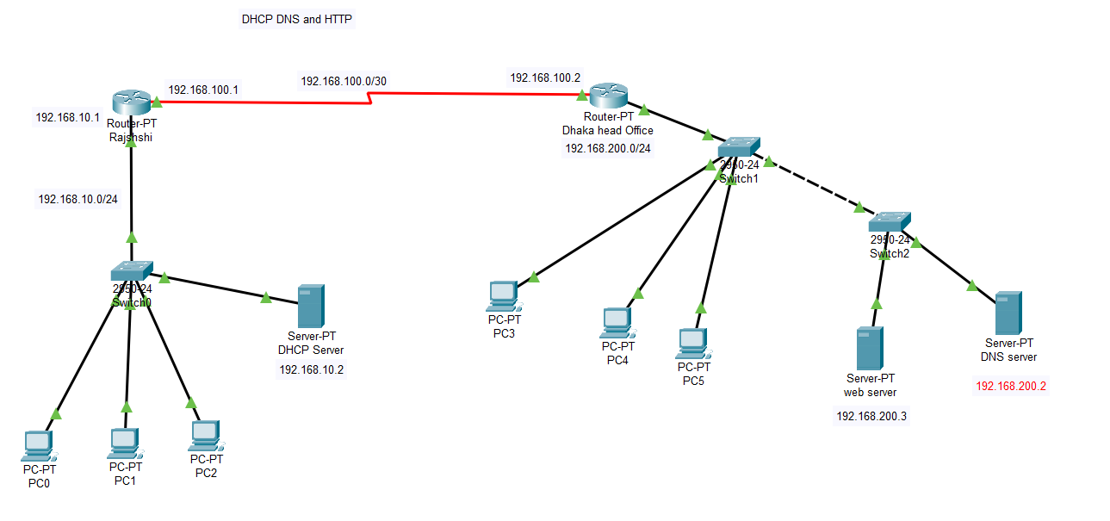

**Route Rajshahi:**

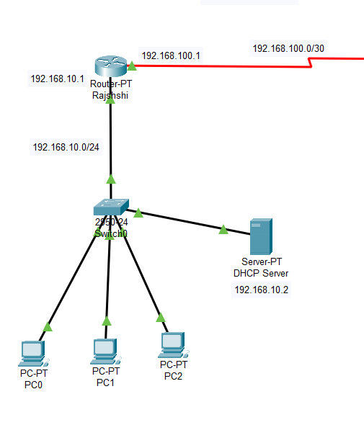

1. Router>en

2. Router#config t

3. Router(config)#hostname RAJSHAHI

4. RAJSHAHI(config)#int fa0/0

5. RAJSHAHI(config-if)#ip add 192.168.10.1 255.255.255.0

6. RAJSHAHI(config-if)#no shut

7.

8. RAJSHAHI(config-if)#

9. %LINK-5-CHANGED: Interface FastEthernet0/0, changed state to up

10.

11. %LINEPROTO-5-UPDOWN: Line protocol on Interface FastEthernet0/0, changed state to up

12.

13. RAJSHAHI(config-if)#int s2/0

14. RAJSHAHI(config-if)#ip add 192.168.100.1 255.255.255.252

17. RAJSHAHI(config-if)#clock rate 64000

18. RAJSHAHI(config-if)#no shut

19.

20. %LINK-5-CHANGED: Interface Serial2/0, changed state to down

21. RAJSHAHI(config-if)#no shut

**Routing Dhaka head office:**

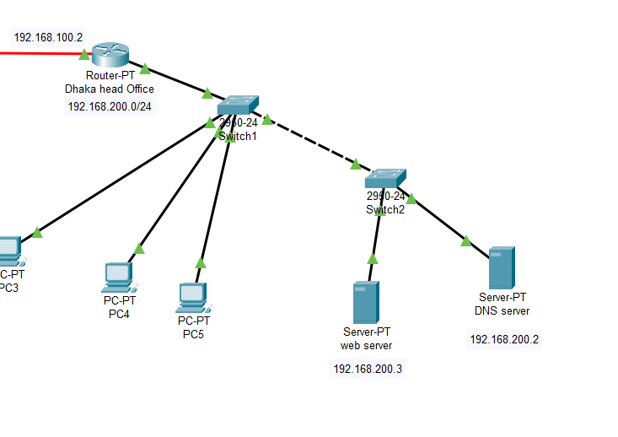

1. Router>en

2. Router#config t

3. Router(config)#hostname DHAKA

4. DHAKA (config)#int fa0/0

5. DHAKA (config-if)#ip add 192.168.200.1 255.255.255.0

6. DHAKA (config-if)#no shut

7.

8. DHAKA (config-if)#

9. %LINK-5-CHANGED: Interface FastEthernet0/0, changed state to up

10.

11. %LINEPROTO-5-UPDOWN: Line protocol on Interface FastEthernet0/0, changed state to up

12.

13. DHAKA (config-if)#int s2/0

14. DHAKA (config-if)#ip add 192.168.100.2 255.255.255.252

17. DHAKA (config-if)#clock rate 64000

18. DHAKA (config-if)#no shut

19.

20. %LINK-5-CHANGED: Interface Serial2/0, changed state to down

21. DHAKA (config-if)#no shut

**DNS and WEB Server**

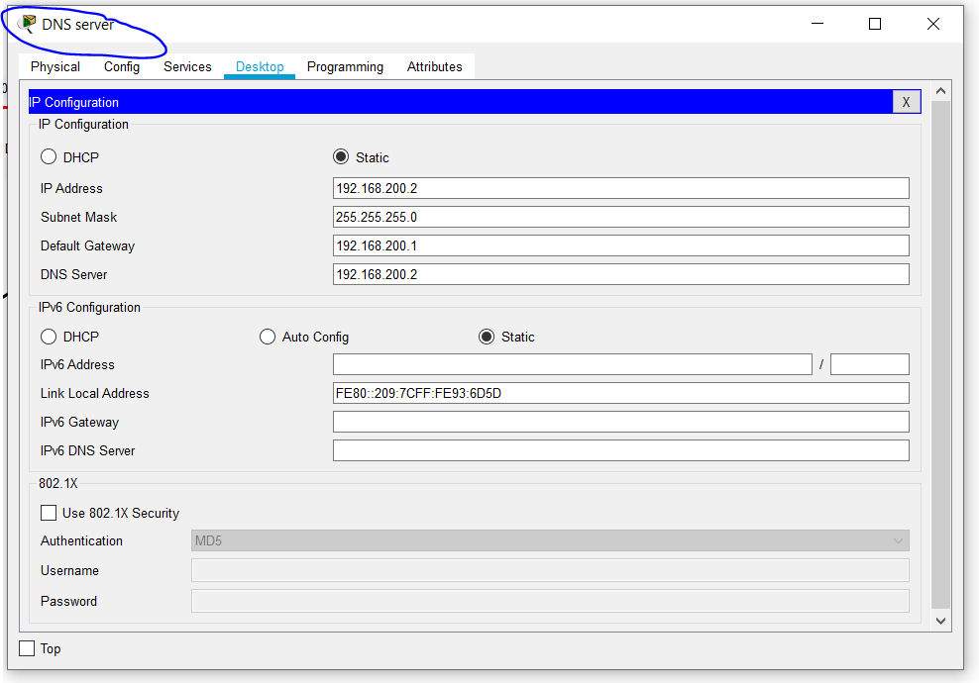

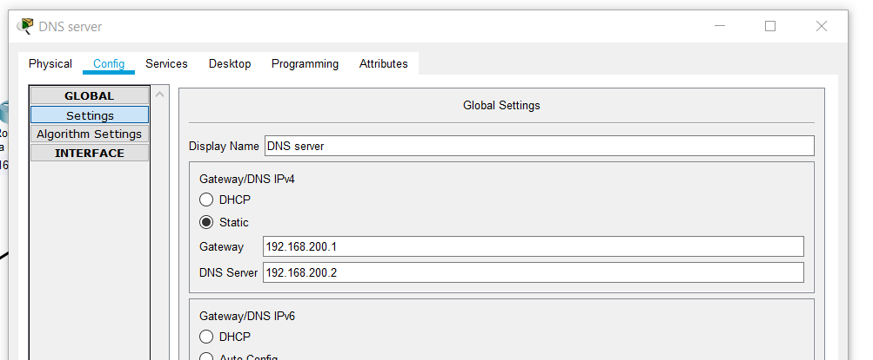

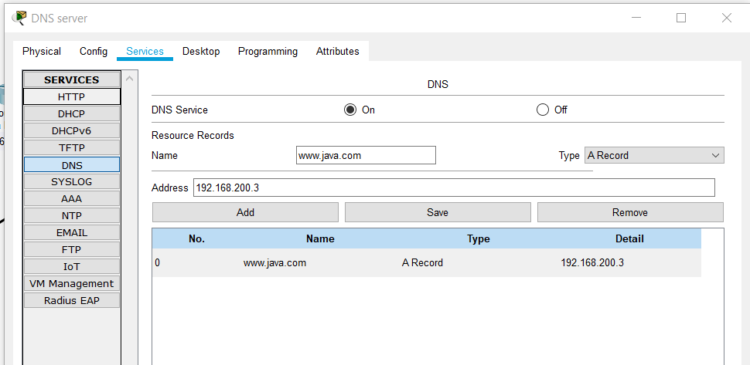

**Web server:**

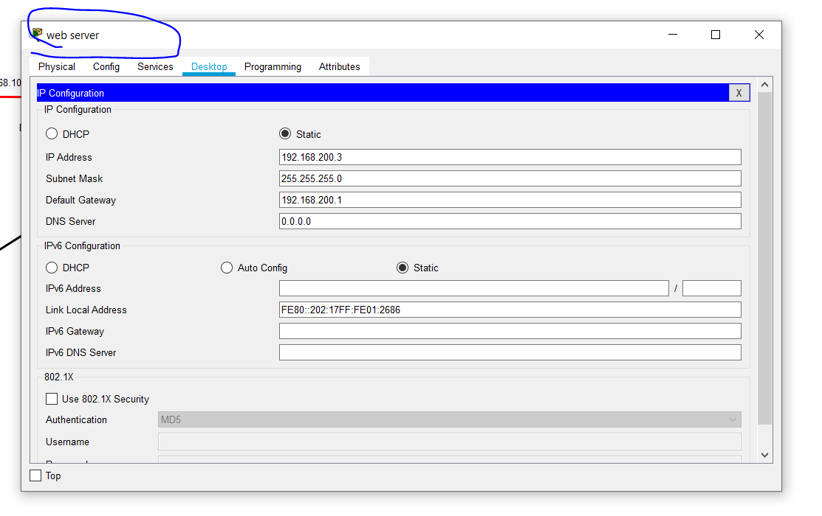

**Checking pc:**

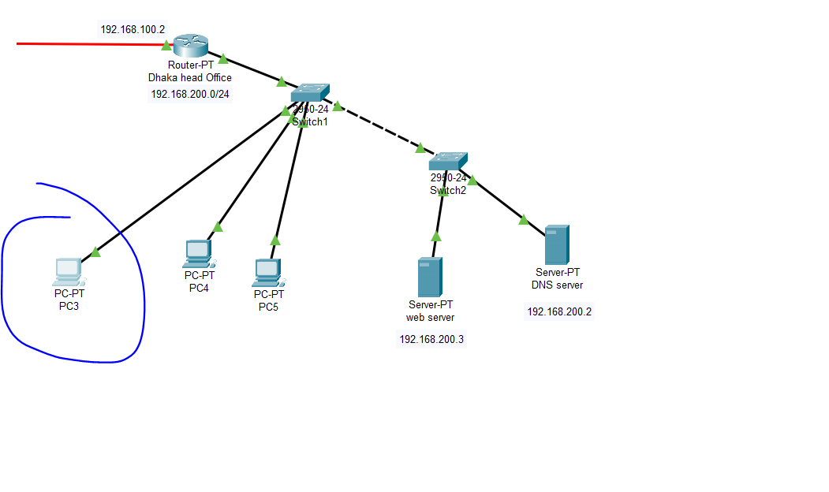

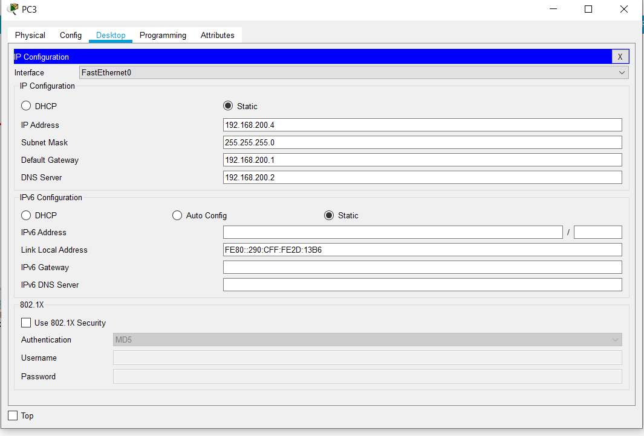

**DHCP Server:**

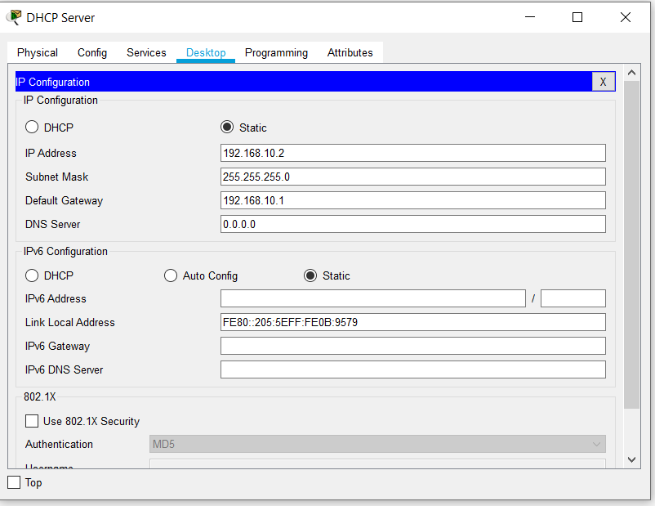

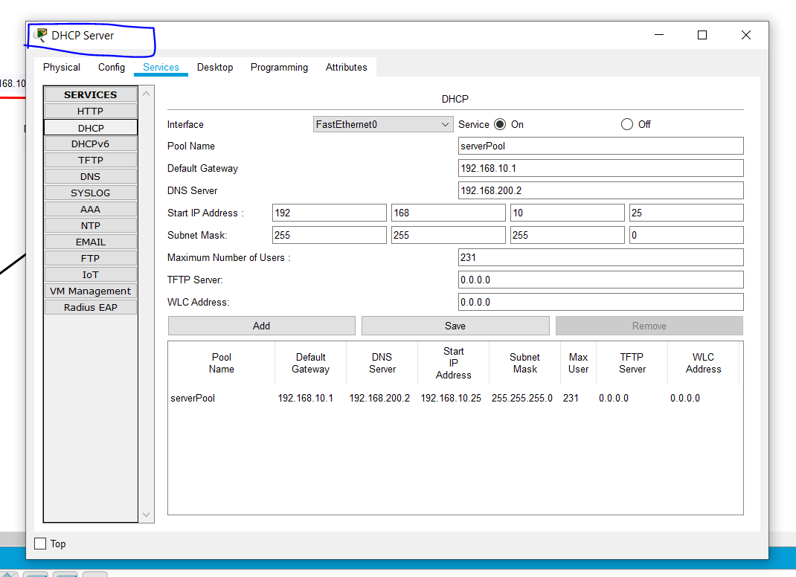

**Static routing:**

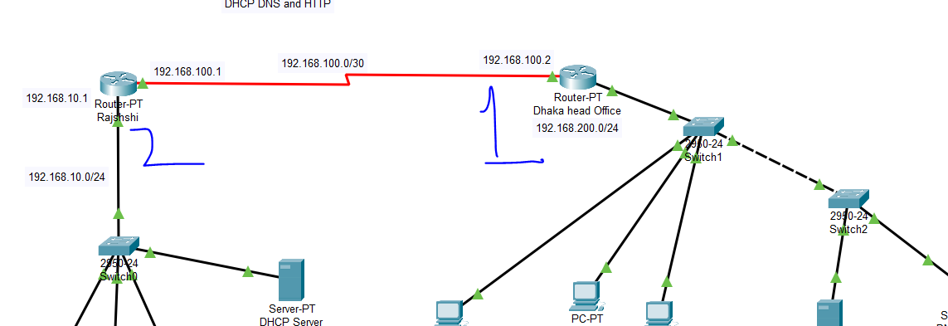

**1:**

1. DHAKA>

2. DHAKA>en

9. DHAKA#config t

10. Enter configuration commands, one per line. End with CNTL/Z.

11. DHAKA(config)#ip route 192.168.10.0 255.255.255.0 192.168.100.1

12. DHAKA(config)#^Z

13. DHAKA#

14. %SYS-5-CONFIG_I: Configured from console by console

15. show ip route

16. Codes: C - connected, S - static, I - IGRP, R - RIP, M - mobile, B - BGP

17. D - EIGRP, EX - EIGRP external, O - OSPF, IA - OSPF inter area

18. N1 - OSPF NSSA external type 1, N2 - OSPF NSSA external type 2

19. E1 - OSPF external type 1, E2 - OSPF external type 2, E - EGP

20. i - IS-IS, L1 - IS-IS level-1, L2 - IS-IS level-2, ia - IS-IS inter area

21. * - candidate default, U - per-user static route, o - ODR

22. P - periodic downloaded static route

23.

24. Gateway of last resort is not set

25.

26. S 192.168.10.0/24 [1/0] via 192.168.100.1

27. 192.168.100.0/30 is subnetted, 1 subnets

28. C 192.168.100.0 is directly connected, Serial2/0

29. C 192.168.200.0/24 is directly connected, FastEthernet0/0

30.

31. DHAKA#

2:

9. RAJSHAHI>en

10. RAJSHAHI#config t

11. Enter configuration commands, one per line. End with CNTL/Z.

12. RAJSHAHI(config)#ip route 192.168.200.0 255.255.255.0 192.168.100.2

23. RAJSHAHI#sh ip route

34. C 192.168.10.0/24 is directly connected, FastEthernet0/0

35. 192.168.100.0/30 is subnetted, 1 subnets

36. C 192.168.100.0 is directly connected, Serial2/0

37. S 192.168.200.0/24 [1/0] via 192.168.100.2

38.

39. RAJSHAHI#